Final Narrative Report

Submitted to : UNDP/UNIFEM

Name of the project | Advocating and capacity building for Women decision makers in Peja Region (Klina, Istog, Peja, Deqan)
Municipality/Region | Klina, Peja, Decan and Istog
Start-up Date | 05.05.2008 | Completion Date | 15/09/2008

Executive summary:

Women’s NGO “ZANA” in cooperation with Local municipalities will developed and organised:

- Five days training seminar on Advocacy and Implementation of Mechanisms for Gender issues in Peja region for 41 elected women assembly advisers;
- Organize at least one visit to the Kosovo Assembly and Office for Gender affairs within Kosovo Government, with the aim of establishing an additional channel of communication between above mentioned institutions and local political representatives of Peja Region - 4 Municipality assemblies.
- Preparing and Publishing a Monthly Hard copy and E-Bulletin/Newsletter on women politicians representing all political parties of above mentioned region with the aim of increasing communication between women voters and women politicians.

The project was focused on raising awareness of women politicians on gender issues, Implementation of Mechanisms for Gender issues, and increased communication between women voters and women politicians so that they will become more actively engaged outside of their usual Political Party meetings and Assembly gatherings. This will be possible by exercising positive pressure on all levels of governance, in particular through a greater involvement of women in these processes, by creating a lobbying strategy as a mechanism to bring their interests closer to the agenda of the institutions in Kosovo and vice versa.

Project Objective:

- To build capacities and advocate for implementation of institutional mechanisms for the participation of women in decision-making processes – through training in lobbying and advocacy, bilateral institutional cooperation and increasing visibility of women politicians;
- To provide access to information and increase the transparency of elected representatives;
- To provide support for raising awareness on women’s rights and gender equality on a local level – through cooperation with local authorities and local women decision-makers;
- To strengthen the link between NGOs and Local governments by organizing trainings held by trainers representing Civil society activists;
- To establish a regular promotion tool in order to increase the visibility of women representing political parties and activists for women’s rights.

Activities: (Include report on project delivery process/ activities that were undertaken during project implementation)

Activities, First Phase: In coordination with Local assemblies and Offices for Gender equality in Klina, Istog, Peja and Deqan, NGO “ZANA” in cooperation with partner organizations organized a 5 days training session on Advocacy and Implementation of Mechanisms for Gender issues in Peja region for elected women assembly advisers: 9 women local assembly advisers from Klina Municipality, 9 women local assembly advisers from Istog Municipality, 12 women local assembly advisers from Peja Municipality, and 11 women local assembly advisers from Deqan Municipality.

The training seminars prepared the participants to engage in raising awareness and implementing Mechanisms for Gender equality in their respective Municipality Assemblies, strengthening women’s role in decision making, monitoring gender equality and advocating for the solution of problems faced by the inhabitants of Peja region – especially in promoting women’s rights. The concrete results of these training seminars are the establishment of women leaders in the local level and creation of a new channel of cooperation with Kosovo Civil society organisations to deal with the women related issues on a local and regional level. Particular focus of the training sessions will be on advanced strategy building mechanisms for lobbying and advocacy of women politician’s interests and gender related issues. The short term aim is to establish and consolidate a core group of women politicians supporting a viable channel of communication between local communities and the Kosovo institutions. Participants will represent women politicians of all political parties present in Local Assemblies in above mentioned municipalities without any political party exclusion.

Project contribution:

Our project contributed in the involvement of women in politics and voting helping them in building their consciousness and empowering them in the decision making processes as well as in their job promotion having into consideration that through them the role of women is advanced is advanced and more conscience among them

Number of scroungers:

The number of scroungers from our project in the direct way is 43 counsellors and there is a bigger number in an indirect way having into consideration society, family, and environment where they work and live.

The activities taken during the project:

During the first faze of the project we had consulting meetings with four municipalities of Peja Region, with the mayors of the respective municipalities where we received the response that they will support all the initiatives dealing with women emancipation in the society so that they receive the working places based on their job and their engagements. During these consulting meetings we met also the officials for gender equality and chairmen of the forums of the political parties as well as preparing and holding of a training session as well as preparation for the first number of bulletin.

New event in the project:

As a new event in the project is to be mentioning the big number of interested women to be a part of the activities during the project implementation, as well as undertake of the action for solving the problem of the gender equality official and sending her back with the office in the municipality of Deqan.

It means that counsellors along with the project staff members initiated one advocacy process which process will be successful since we are supported by the others, too.
Unexpected problems during the implementation we haven’t had since everything was planned and all the activity was done based on our plan. The well being of the activity can be seen from the list of the participants, their pictures as well as monitoring process that was done by the donator.

Actions that received solutions:

Actions that received solutions during the implementation was, the right understanding from the participants and undertaking of the action to advocate to the Deqan municipality for taking back the office for gender equality into the municipal building.

Materials presented in the report show the jobs and main results, during the implementation of the project: Advocacy and capacity building of the decision-making women from Peja region” which project was implemented for 4 continuous months in Peja region ( Peja, Klina, Istog and Deçani).
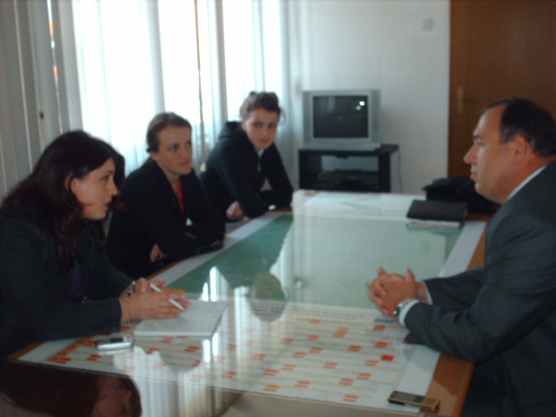
Meeting, Klina :08.05.08

In this aspect we had meetings with Mayors of Peja Region Municipalities, with the officials for gender issues and with the presidents of the forums of the political parties, with representatives of the civil society, where we were supported for the abovementioned project, describing it as very important in regards to mutual cooperation. Continuous attempts of many women to achieve the gender equality were and are many, but they didn’t give enough results. In this case even our organization attempted to build alliances with different women NGO-s and decision-making women, as a strategy to assure the equal participation in all the levels of decision-making in politics. During the first session was said that we pretend to be a part of the civilized society, we should respect the law for gender equality as a prior condition in fulfilling the standards to become a part of the European Union.
However, it is needed that women to be very much united starting from nongovernmental section, media, and private sector, to propose progressive and sensitive approach from the gender perspective, in order to treat basic issues of the political, economical and social development
In order to achieve the proper improvements in this regard, women should listen to the ideas and opinions of each other, initially working in building their own capacities, then creating the strategy of the work to achieve what they want.
Starting from the fact that there is a law for gender equality approved and we have officials for gender issues, it doesn’t mean that we reached the gender equality, but we have to coordinate things in order to achieve the desirable results; was the opinion that came up from the women members of the municipal assemblies of Peja region during our first meeting
As it was said by women councilors, Kosovo society is moving in right lane into assuring the stabile boosting of the equal and effective participation of women in decision making in politics.
However, kosovar women are still facing a number of challenges, but they should work much more since there are young and talented women to be engaged in politics. Similar training and consults will continue in the future too in order to strengthen the ties and determinations of the decision making women in all the sectors into achieving the gender equality.

However during the training sessions was stressed that democratic governance requires quality and determination so that she becomes the bearer of all the positive processes in the society and to contribute in the overall European integrations.

The exercise of the political power requires the successful management full transparence.
During the training sessions were stressed also the political, social, economic obstacles that women meet such are: lack of trainings for the women with communicative capacities to become active, poverty and very often mentioned traditions that see women only as mothers and wives.
If they want to gain wider support and mobilize women voters, women should use strategic communication methods and make the framework in order to respond to the public interests.

From this it came up that women should improve communication abilities as a tool to get more power in politics and to be as clear as possible in their presentations.

In regards to approaching the decision making women with women voters it was said that the best way of the communication between the decision making women and women voters is through direct and media communication as well as mobilization of women voters where they want to see where a bigger attention of the government towards taking care of children, education, would give to the women more free time for their own economic development, enabling them to take support themselves and families generating more incomes. The society where more than 50 % of the population is marginalized can not be developed.

So, politician women should focus in the practical needs of the women voters, understanding important issues in order to help them and have them as supporters. Woman more and more is becoming an active subject of political and social live and in this regard also a key element in representing the interests in the municipal assemblies, not only women interests but also to the people they represent. The women voice should be much stronger and they should be ready to face the challenges in exercising the political, financial and economic authority.
They should engage so that to justify the trust given to them, not only with the fact that they are represented by 30% in municipal assemblies, but with intellectual capacity to undertake initiatives for the general interest.

Regarding the capacity building of the women councilors of the region there are still needs for support in different aspects. The present problems are a concept of addiction by the political subjects therefore the support of more projects would have big influence in developing positive changes in the decision making processes.

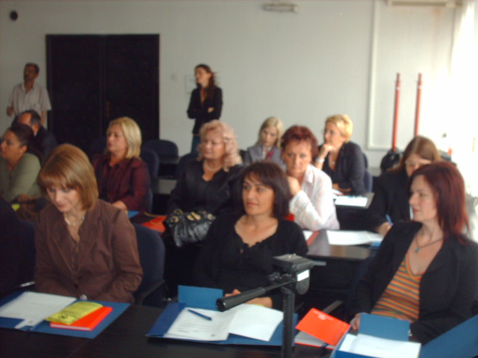
Democratic governance-human right and the law for gender equality, Klina :22.05.08

During the training sessions was re-stressed the need for cooperation building partnership among women NGO-s and women in Politics, and that without the mutual cooperation there wont be success.

During the training sessions came up that it is visible the improvement of the position of the women in decision making processes, comparing today with 10 years ago there is an improvement but we should work harder to reach where we want to.

It was also mentioned that women should raise their voices more in regards of respecting their rights, because woman is a main pillar of the family and other processes as well, so that she deserves moral, social and institutional support. Our women should increase her own capacity more and more and find out her capabilities. These capabilities are developed only if they follow the education.

The general overview in our region shows low participation of women in political life. Usually women became more active if their problems are not addressed in a proper way.
In context of political participation, under the pressure of present election laws, it is increased the level of obligate quote for women in public institutions.
During the session it was evaluated that this more a tendency of more educated women and those from cities. Women living in the villages should educate more for the need of political participation.
In context of political participation, under the pressure of laws, the level of women being voted is increased very much. But this is more a tendency more educated women and those from the cities.
Women from rural areas are facing the problem of the bad infrastructure and not regular local transport.
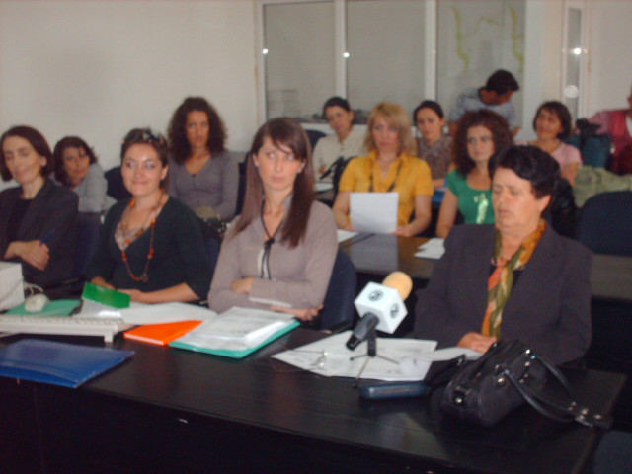
Good governance-public partnership- private:Klina,03.06.08

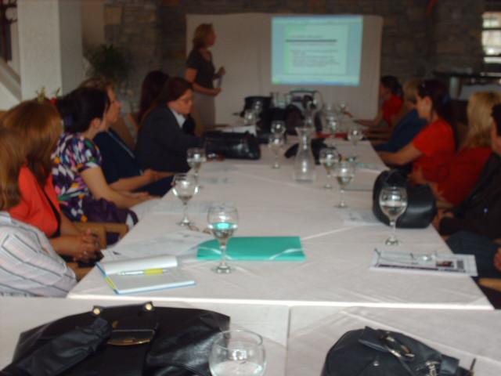
Management of Finances in Municipalities,Istog:14.06.08

During the session it was mentioned that other factor or problem that influence the participation in politics is illiteracy.
In general women are more affected by this problem than men, with 10.2 % illiteracy.
Participation in the local governance is the crucial step to ensure participation of women in central elections as well as ensuring leading roles in state decision making.

Among other it was said inequality and discrimination the women are facing, among the other is influenced by traditional attitude and limited expectations with stereotypes towards women.

Law for gender equality in Kosovo brings forward specific recommendations and actions that should be taken by local government.
In regards the support by local government to the women NGO-s , it was said that there are few mechanisms. Some of the municipalities have a point in their budget lines reserved for local NGO assistance.
In some municipalities these funds are mainly limited, as it is the budget of the municipalities in general, mainly because of previous centralized government system, and budgetary.
One of the difficulties present during the gender issue lobbing, regardless it is for creation of gender commissions, gender financing or employment, is general lack of information’s or classified data from the gender aspect in municipalities or nationals level.
Classified information’s in the gender aspect would properly ensure information’s for gender disperse and women representation in state and private institutions, and they would serve as a base for formulating requests and certain actions.

During the session it was evaluated that chances to influence in decision taking for municipal financing are bigger if the NGO-s of the same municipality cooperate, and propose to the municipalities’ joint agendas, and this tactic is recommended in the cases where there are few women NGO-s
Women NGO-s can support the initiatives or important issues such as: careful expenses from gender aspect of the municipal budget, and can coordinate well all key organs involved in preparation, approval and implementation of municipal budgets in order to ensure gender sensitivity of the budget

During training sessions was said that local media are very much a strong instrument that can be used in achieving the goals in advocacy and help in consciousness building for problems and women issues.

Recommendations from the training sessions:
First session: democratic governance-human right and the law for gender equality.

- To create groups of interests from civil society and political parties’ forums, that would advocate for different problems and would work in empowering their position and improving things in the overall interest.
- To increase the number of women in decision making positions, so that 30 % not to be just a number but also quality.
- To select a group to advocacy the return the official for gender equality in the municipality of Deqan in the municipal building.
- To use media, civil society, and gender perspective in all the aspects of political life in order to increase the representation of many more women in politics.
- To function the comities for gender equality in municipalities, implementing the law for gender equality.

Recommendations from the second session: good governance-public partnership- private

- creation of one group to see closely the job of the procurement offices
- All documents for the public to be published in municipal web pages.
- to create groups for monitoring the tender distribution ( selection)
- in the future to organize meetings in order to exchange experiences among Kosovo, Albania and Macedonia ( respectively municipalities of our neighboring countries)
Recommendations from the third session: finance management in the municipalities

- To be published in the municipal web pages the expenses of public money
- Customs to be more efficient in their job.
- Property tax to be lower because the number of population lives in the extreme poverty.

Recommendation resulted from third session: Management of Finances in Municipalities

1. To be published on Official Web Site the information where the public founds were spent.
2. Custom Service to be more efficient in their duties
3. To reduce the taxes for the real-state as per the fact that a part of citizens are living on extreme poverty conditions.
4. To strengthen the cooperation of Civil Society and the Authorities concerning combating the Human Trafficking.
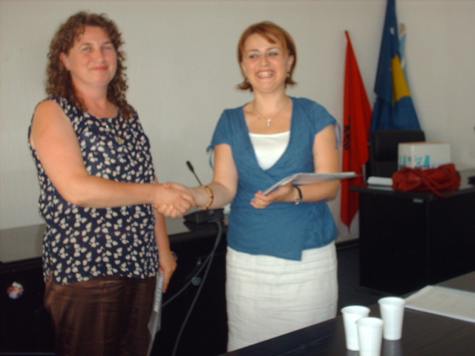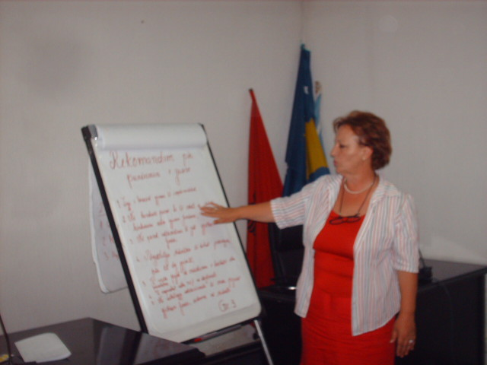
Gender Mechanisms,Klina:08.07.08 Gender Mechanisms ,Peja:07.07.08

Recommendation resulted from the fourth and fifth sessions: Gender Mechanisms in Local Authorities – Assessment of requirements

Recommendations from Group for Gender Mechanisms:

- Implementation of law for Gender Issues including as much as additional mechanisms (directorates, comities and other authorities)
- Fighting the Illiteracy

- Cooperation with Political Forums, NGO-s and Media.

- To pay especial attention to implementation and monitoring of law.

- To work aiming presence of females in decision making in all sectors of life, especially in key sectors not only in those of gender issues.

- Improving the status of Officials for Gender Issues, to increase their participaltion in local governance decision making especially.

Recommendation from Group for Empowering the Female in Politics

- To train the NGO-s for using the Media as tool for empowering the females in politic
- To include the new female members in politic
- Promotion of female political leaders that can present a positive sample
- To train females candidate and political leader on issue of using the media efficiently to communicate with voters
- To start lobbing for further democratization of political parties in a transparent process of selection of candidates and empowering the female’s organizations within political parties.
- Promotion of female candidates proving that the politics they present corresponds to present priorities.
- Founding strong alliances of NGO-s, for empowering the female’s presence in politics
- Developing programs for involving young girls in politic
- To increase individual capacities of female candidates to become winner candidates.

Recommendations from Group for Improvement of Health Care:

- Sufficient supplying of health care centers with essential medicaments
- Founding a specialized team for emergent cases
- Functionalizing Health Case Stations in Rural Zones
- Advising centers for Pregnant Women’s and New Mothers
- Organizing Training Sessions for awareness of females regarding the importance of hygiene.
- Providing a medical team at schools
- Education about Family Planning

Recommendation of Group for Finding jobs for females:

1. To implement the Law for Gender Issues
2. In Vacancy Announcements to include the female gender too
3. To force the 30% also for posts of Director
4. In institutional leadership to participate the woman too (especially schools)
5. Females to be included in the interviewing team for testing candidates too
6. To have into consideration the academic level for both genders
7. Participation in drafting of budget

Implementation of Law for Gender Issues

During the meeting with high officials from Agency for Gender Equality and advisers of Prime Minister was emphasized that: “meetings of this nature are highly important to be informed for the progress made in implementation of Law for Gender Equality.
We were briefed that the Prime-Minister announced month September as Month of fighting the Discrimination of Female, as Kosovo is leads for good against other regional countries for fulfilling the standards. The Law for Gender Equality is empowered since year 2004, and targets its total implementation due to European standards”.
High officials from Agency for Gender Equality said “The agency is functional since year 2005, divided in four sectors doing all possible to implement the law for gender equality, against difficulties encountered the implementation of the law is progressing lowly as 12.5 % of females in Kosovo are illiterate and this is obstructing the implementation of the law. Another obstacle encountered is lack of interest from municipal leaders to found the office for gender equality and sharing the founds for functioning of the office, although 30 % presence of females in standard for European Integration.

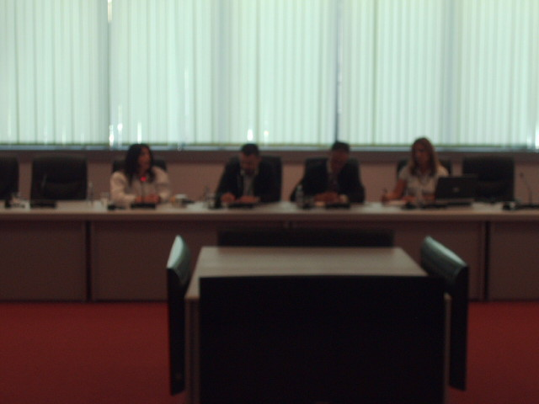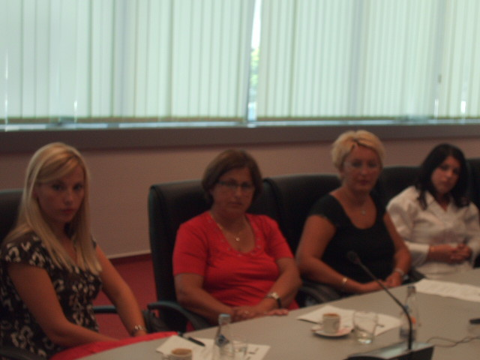

Implementation of Law for Gender Issues,Prishtina;04.09.08

Should be emphasized that the political, economical, social and other problems that kosovar society is encountering is attracting attention far from problem of respecting gender equality.

In this contest should emphasize that the meeting with Agency for Gender Equality aims direct contribution on engaging the females in politics and their empowering in politic.

Should emphasize that the Kosovo Protection Corps (Kosovo Security Force) and Kosovo Police succeeded empowering the female by increasing the presence of female in leadership, 15.5 % of Kosovo Police are females and 12 % in leading posts.

Thus to move forward in realization of Gender Equality especially in decision making is needed more engagement from main and local structures.

The society should increase its pressure to functionalize these structures; consequently it was considered necessary organizing of campaigns for gender issues, through more often meeting with leadership, political parties and civil society.

Media must play its very important role as effects strongly in creation of public opinion.

Another issue brought out was that the Office for Gender Issues within municipalities should have more support by the Municipal Assemblies as that will improve the presence of females especially in rural areas.

The project all the time was interesting from medial such as TV-21, daily press, Local Radio ” Alba ”, Radio Kosova, thus we can conclude that was done a great job for the woman in decision making as they are mostly affected by the political parties they come from.

Date:15.09.2008 Submitted by: __________________

